**Webinar:**

**”DeSIGNed Europe for Deafblind Women”**

**22nd of October 2020.**

**BOOK OF SUMMARIES**

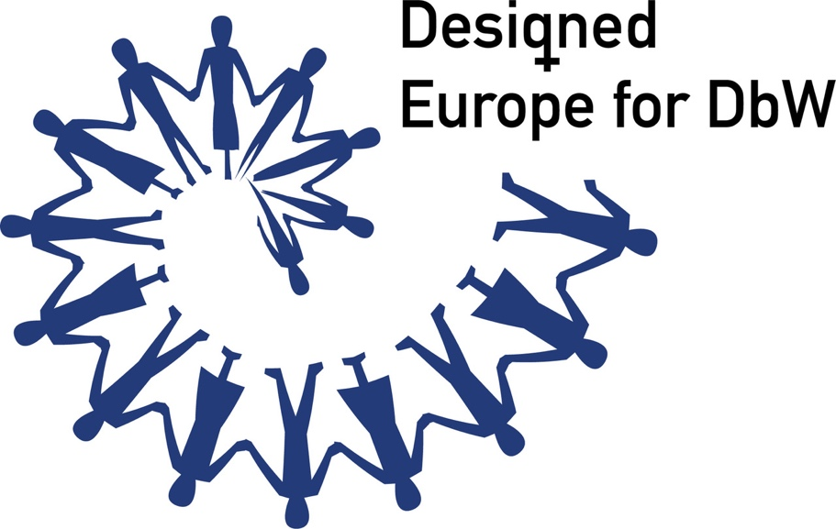

This product was financially supported by the National Foundation for Civil Society Development.

The contents of this audio (visual) production are the exclusively responsibility of the author and do not necessarily reflect the views of the National Foundation.

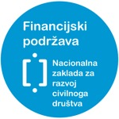 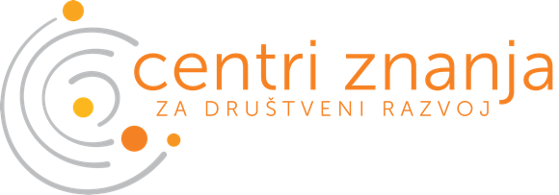

**CONTENT**

**PREFACE**..........................................................................1

**MEETING WELCOMING SPEAKERS**.................................2

**VOICES OF KEY SPEAKERS**...............................................6

**Ana Peláez Narváez**.........................................................7

The Impact of the Pandemic on Women and Girls with Disabilities, with Special Focus on Deafblind Women and Girls...................................................................................8

**Anka Slonjšak**....................................................................9

Women with Disabilities-experience of ombudsman for persons with disabilities in Croatia ..................................10

**Petra Palenkaš**..................................................................11

Deafblind Women and Career Development………………….12

**Sanja Tarczay**.....................................................................13

Discrimination or Activism? How to find a Db woman’s way?...................................................................................14

**PREFACE**

Dear deafblind women and girls, colleagues, associates and friends,

**Due to the COVID-19 outbreak The European Deafblind Union (EDbU) and Croatian Association of Deafblind Persons Dodir” had to cancel its *4th EDbU Conference “DeSIGNed Europe for Deafblind Women" that was supposed to hold in May 2020. In Zagreb, under the Under the auspices of the Croatian Presidency of the Council of the EU 2020.***

That is why European Deafblind Union (EDbU) and Croatian Association of Deafblind Persons “Dodir” decided to hold the on-line event via Webinar on 22nd of October- European Deafblind Day!

EDbU as a voice of Deafblind persons in Europe has a tradition of supporting a deafblind women and had established its Deafblind Women’s Group in 2013., Bulgaria since when is actively supporting its work.

Deafblind people in general are facing many obstacles and challenges in everyday reality, but Deafblind women moreover have to fight with multiple discrimination and inequality based on their gender as well. That is why we would like to point out the importance of the supportive and inclusive environment, from family to work, education, right to full participation **(*access to health, communication, justice, public, political and cultural life)***.

**The COVID-19 pandemic and the government response** all around the EU created situations of severe infringement of the rights of the Deafblind persons, especially women where we unfortunately once more witnessed deafblind persons were being excluded, discriminated and forgotten from the society.

**How can we proceed in the upcoming future to ensure that the human rights of persons with deafblindness especially women are upheld in this time of crisis?**

This webinar will explore and aim to bring up a discussion on this topic but as well exchange the practices among countries in EU to build the bridges toward the more inclusive EU designed for deafblind women.

Hope you will enjoy it,

Organisational board



**MEETING WELCOMING SPEAKERS**

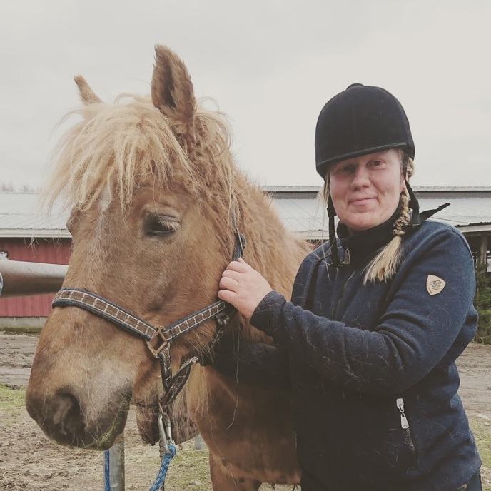

**Sanna Paasonen**

**Chairperson of the EDbU Deafblind Women's Group**

Sanna Paasonen is a deafblind person from Finland. She is a an active member of the European Deafblind Union ( EDbU) but within other organisations as well. Some of her current professional roles are:

* Member of Council on Disability, Mikkeli City
* Member of Ad Hoc Female Sign Language User Group, the Finnish Association for the Deaf
* President, The Deaf Club of Mikkeli
* Ed.M. Senior Specialist, Trainer (especially Sign Language, Disability, Deafblindness, Deafness, Interpreting, Violence)
* Student of the Master Programme in Jyväskylä University (Finnish Sign Language, Violence Research)

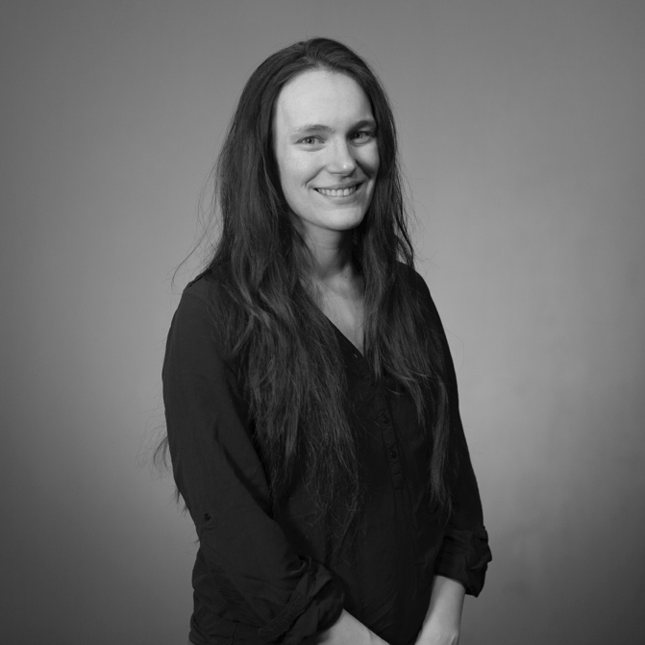

**Stephanie Floux**

**Chairperson of the EDbU Deafblind Youth Group**

Ms. Stéphanie Floux is a 32 years old, deafblind person from France. She is a trainer acquired with professional experience in consultation on accessibility for deafblind persons. Certified from the incumbent following youth organizations under the European Voluntary Service (EVS) in 2011., and on leadership management under Frontrunners, an international program in Denmark in 2012. She also obtained a professional youth certificate, from the popular education and sport (BPJEPS) and is a member of the European Union of the Deaf Youth Training Team. Graduated "Referent in Deafblind" in 2019. in France. Except she is very active member of the European Deafblind Union (EDbU) being the Chairperson of the Deafblind Youth Group, she is the president of National Association of Deafblind Persons in France (RNSA) since 2018. and board member of National Association of Deafblind Persons in Belgium, Anna Timmerman, since 2020. At the moment she is part of the EDbU organisational board for the upcoming EDbU Youth Db Camp in 2021 in Belgium.

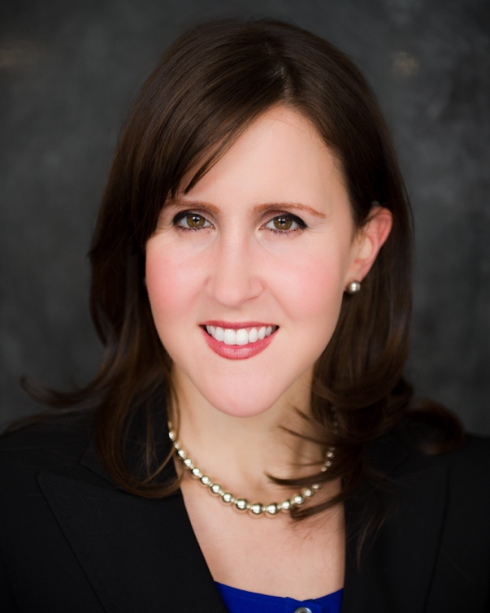

**Kerry Thompson**

**Disability Rights (Advocacy) Fund (DRF/DRAF)**

Kerry Thompson is an American living with deafblindness. She is the Senior Officer for Communications, Inclusion, & Analytics for the Disability Rights Fund and the Disability Rights Advocacy Fund. She is a 2014 Marshall Memorial Fellow with the German Marshall Fund for the United States and a 2016 – 2017 White House Fellowship National Finalist. She serves as the Executive Director for Silent Rhythms Inc., a non-profit that promotes access to the arts and in society for people with disabilities. She is a 2020 Visiting Artist to Harvard University’s Dance Center. Kerry also serves as Vice-Chair on the Massachusetts Statewide Advisory Council. Kerry holds a Master’s in Human Development from Harvard University.



**VOICES OF KEY SPEAKERS**

**Moderator**: Karla Silić

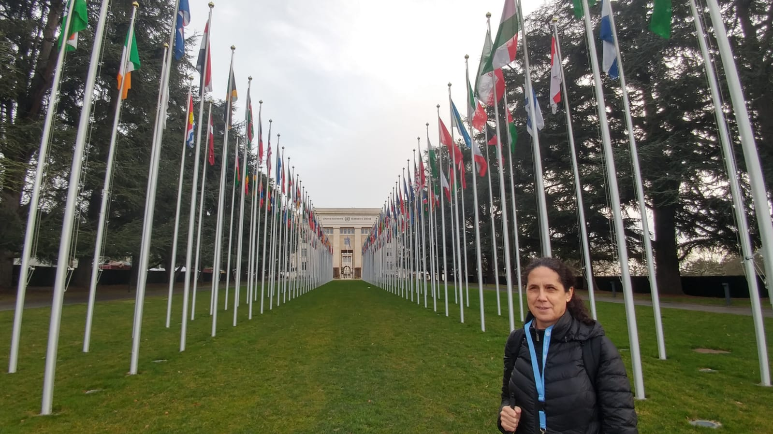

**Ana Peláez Narváez**

**Spanish National Organisation of the Blind (ONCE)**

Ana was born in Spain and is blind from birth.

Her current professional responsibilities are:

- Executive Councilor for International Relations and External Development at the Spanish National Organisation of the Blind (ONCE).

- Executive Vice-President of the ONCE Foundation for Latin America (FOAL).

- Responsible for gender affairs at the Spanish Council of Representatives of Persons with Disabilities (CERMI, the umbrella body for the Spanish disability movement).

- Executive Vice-President of the CERMI Women’s Foundation

- Vice-President of the European Disability Forum (EDF) and Chair of the EDF Women’s Committee.

- Former member of the United Nations Committee on the Rights of Persons with Disabilities (2009-2016)

- Member of the UN Committee for the Elimination of Discrimination against Women (CEDAW Committee) (2019 to 2022).

**“The Impact of the Pandemic on Women and Girls with Disabilities, with Special Focus on Deafblind Women and Girls”**

**Key words:** women with disabilities, women with deafblindness, COVID-19, accessibility

We need first to think about the impact of the COVID-19 on women in general. The first reason is that women in general are considered as care givers which is present during the pandemic as well. The second reason is violence against women which was unfortunately even increased during the lockdown. The third reason is that health workers are mostly women which shows link between women working in health services and COVID-19. Data shows that 20% of the female population are women with disabilities which is not irrelevant number but nerveless they were not included in the response measures by the authorities which I’m going to explain on the real example of deafblind women who do not have access to health care during the pandemic. Moreover, communication accessibility for women with deafblindness is crucial due to the limited access to the interpreting services and even new technologies are big challenge for them as they are often not accessible. Furthermore, for women with disabilities and women with deafblindness it is fundamental to talk about their sexual and reproductive rights during the pandemic which is very concerning. Many women and girls with deafblindness are institutionalised, isolated and excluded and we do not have any data about them. They are exposed to the violence and/or abuse and in those conditions they do not have access to justice. Now we are coming to the problem of violence against women and girls with disabilities, and the data are showing it is now worse than ever due to the lockdown and what is the most concerning is that women are often living with their own perpetrator so we need to detect a key instruments in order to protect them. Finally, they have been facing challenges in access to the education which leads to the problems with employment as well. Nothing about us without us, is a fundamental motto to be followed as well SDGs. That is why it is necessary for women with deafblindness to have their own commissions and to network as well with other women with disabilities so that we can ensure no one is left behind.

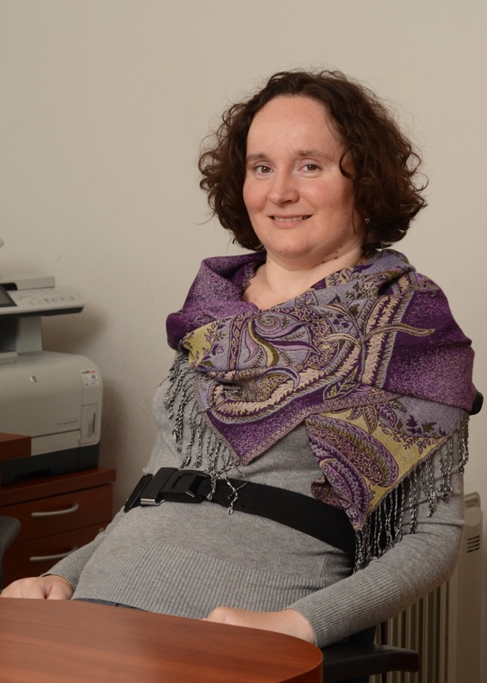

**Anka Slonjšak**

**Croatian Ombudsman for Persons with Disabilities**

In 2008. Anka Slonjšak was appointed as the first Croatian Ombudsman for persons with disabilities by unanimous vote of the Croatian Parliament. She was reappointed unanimously for her second 8 year term of office in 2016. Where she built up the institution of the Ombudsman for persons with disabilities and positioned it as an important stakeholder in protection, promotion and monitoring of the rights of persons with disabilities with a strong international presence. Before becoming an Ombudswoman she worked with OCS and managed and coordinated numerous activities as member of the Croatian Paraplegic and Tetraplegic Alliance and Croatian Union of Associations of Person with Disabilities (SOIH).

**“Women with Disabilities-experience of ombudsman for persons with disabilities in Croatia”**

**Key words:** women with disabilities, COVID-19, accessibility, communication tools, empowerment

Women with disabilities are a particularly vulnerable group whose visibility in the public sphere is very difficult to show. Unable to access communications, transportation, and general information, women who are blind, deaf or deafblind are also denied or restricted from access to educational, professional, economic, social, and political opportunities, leading to social isolation, and often remaining trapped within their fragile social network. Insufficient public awareness of the difficulties that these women face daily, as well as a lack of support, be it the service of a seeing companion, or architectural and orientation accessibility leads to behavioural and emotional difficulties.

Insufficient awareness and accessibility of health services, especially in rural areas, results in a worryingly low response of women with disabilities to preventive gynaecological and mammography examinations. We continuously emphasize the need of multidimensional support, and accessible information in various formats through which a woman could get acquainted with all challenges of motherhood, without prejudices. The unfavourable position of women in the labour market has a long tradition, and is even greater for these women, who are represented as an unprofitable working group. Any form of disability that requires additional investment, is seen as undesirable by employees and is usually a decisive factor.

During aging, many women with disabilities, due to insufficient medical staff and their insufficient knowledge of communication tools, become more and more dependent on the help of others, and, in addition to their primary impairment, further impairments which often stay neglected, become to develop.

At the time of the Covid-19 lock-down, communication posed a challenge, including the transmission of the necessary up-to-date information, for example the translation into sign language or subtitling text on television programs. For this to change, we must continuously encourage awareness, positive changes, and empowerment of women.



**Petra Palenkaš**

**Chairperson of the Deafblind Women’s group in Croatian Association of Deafblind Persons “Dodir”**

Petra Palenkaš is young deafblind woman from Zagreb, Croatia. In 2014. She finished her Master degree in Inclusion Education and Rehabilitation at University of Zagreb. After finishing the University she was working in different kindergartens and currently is employed in kindergarten “Velika Gorica”. During her student years she was very active and volunteering with children with disabilities and in Croatian Association of Deafblind Persons “Dodir” where she is currently Chairperson of Deafblind Women’s group. In her free time she is active as well, working on her professional and personal development by attending conferences, educations, and workshops. She is passionate dancer and she finished Dance school “Guy Perkov”, moreover she finished a six year music school programme in “Elly Bašić“ Music School.

**Deafblind Women and Career Development**

**Key words:** deafblind women, special education teacher,reasonable adjustment

As a deafblind person from birth, this lecture is focusing on a speaker’s own experience as young deafblind woman from Croatia and her story of becoming a special education teacher. Even the path was not easy and full of challenges the aim is to empower other women with deafblindness that it is not impossible.

During her education, from Elementary school to the University she faced a situations when inclusive education was just an idea but did not exist in the practise. But that did not discourage her to be an excellent student and have great grades even it meant to always do more, and try more. Moreover it affected her social life and working much more than others. But there is time when you have to set the limits and except that the disability is part of you and not something you have to explain to your teachers, colleagues and others why you cannot do something but they should be aware that there is always a way- different way. Excepting who you are is a process but even it can be challenging it is achievable.

After getting a degree and successfully becoming a special education teacher she did faced more challenges while looking for a job. When applying for a job she received a comments like: “We invited you as we saw you are deafblind and we wanted to know can you walk.”. Those were difficult times of proving to everyone who she is and what she can to despite of her disability. After few battles she found a job in the kindergarten where she is currently happily employed. But it was not like that from the beginning, she had to fight for it and advocate for herself to achieve reasonable adjustment. What is important for other deafblind women to remember is that even it is good to put effort into something you really want, like be the best student, the best employee, you cannot push yourself too hard. Deafblindness as a part of the identity is not something that you accept overnight but it is important to work hard on that despite often changes you are facing. For every deafblind women out there it is important to know yourself so you can choose your direction, and not let others decide it for you.

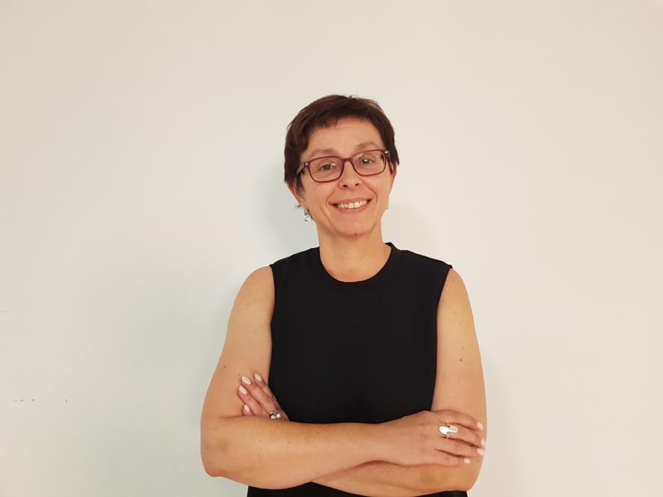

**Sanja Tarczay, Ph.D.**

**president of the European Deafblind Union (EDbU)**

Sanja Tarczay was born in Zagreb, as a deaf child in a deaf family and later became Deafblind person. In 1994, she established the Croatian Association of Deafblind Persons – Dodir –where she currently serves as President. She is the creator of a Croatian Sign Language course, courses for SSP’s, courses for Sign language interpreters and Deafblind interpreters and the founder of the Croatian Sign Language Interpreting Centre.

From 2001. till 2013. she was a member of the World Federation of the Deafblind Executive Committee where she was also a representative for European region.

Since 2008.-2018., Sanja has been the practicum leader for a module on Deafblindness at the Faculty of Education and Rehabilitation Sciences, University of Zagreb. Today she is still a lecturer on Sign Language at the University of Applied Health Studies and on Faculty of Teacher Education in Zagreb. She has also lectured at numerous other universities abroad and has published several research papers. In 2013, she was elected President of the European Deafblind Union. She is Member of Grantmaking Committee inside of Disability Right Fund (Massachusetts, USA) and a Board and Women’s Committee Member of the European Disability Forum, among others.

Sanja earned her Doctorate degree in 2014. She is fluent in five Sign Languages.

**“Discrimination or Activism? How to find a Deafblind woman’s way?”**

**Key words:** EDbU, deafblind women, fourfold discrimination, activism

The EDbU is an international non-governmental organization, located in Brussels, Belgium whose currently motto is „Nothing about Deafblind without the Deafblind“.

But while the deafblind persons in general are facing everyday discrimination and challenges, deafblind women have to fight with multiple discrimination due to their gender as well. In this lecture I will explain the term „fourfold discrimination“ of Deafblind women based on their gender, disability, sensory deprivation and socio-economic exclusion and give the example for each of them.

Moreover, I will represent the data from the EDbU survey, conducted in 2019. which was to discover the activism of Deafblind women. We have received a 14 responses from each National deafblind organisation that showed less of 50% have majority of the women in their Executive Committees. Also responses showed that just 4 countries have a deafblind women involved in national or local level politics. I believe that these results are showing a fundamental problem of lack of professional Deafblind interpreters, lack of information and education for deafblind women and invisibility of deafblind women in public and political life in general.

That is why we need to shift perspective to empower deafblind women to achieve equal access and full participation in the society to gain the ability to make their own decisions. One of the ways is the EDbU Deafblind Women’s Group which is on the great way of creating a strong Deafblind Women's movement!

# 

# **European Deaflblind Union (EDbU) Contact:**

**E-mail:** **edbu@edbu.eu**

**Web page: http://www.edbu.eu/**

**Facebook page : https://www.facebook.com/The-EDbU-The-European-Deafblind-Union-1606483702904962**

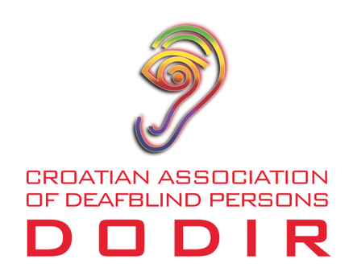

**Croatian Association of Deafblind Persons Dodir Contact:**

**E-mail: dodir@dodir.hr**

**Web page:** **https://dodir.hr/**

**Facebook page: https://www.facebook.com/savezdodir**

**This webinar is under the auspices of the Croatian Ministry of Labour, Pension System, Family and Social Policy and the City of Zagreb.**

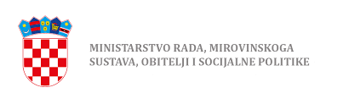 

**This product was financially supported by the National Foundation for Civil Society Development.**

**The contents of this audio (visual) production are the exclusively responsibility of the author and do not necessarily reflect the views of the National Foundation.**

